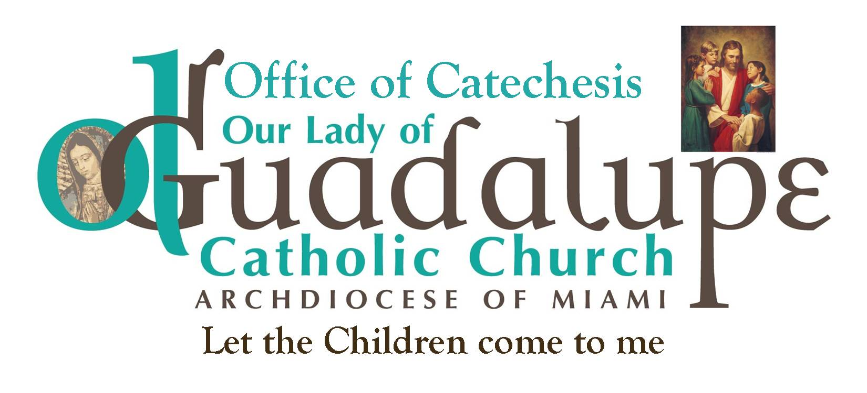

The Four Pillars of our Faith
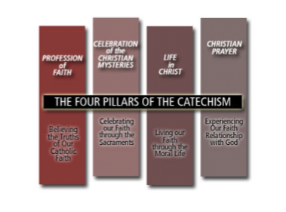

Credits: www.lancasterdiocese.org.uk/the-catholic-faith/

The First Pillar: The Creed — The Faith Professed
When we pray or recite the Creed, we can be reminded that Catholicism is a revealed religion. God is the author of our faith. All that we are expected to believe is summed up in the revelation of Jesus Christ. God has spoken all that is necessary for our Salvation in Jesus, the Word made flesh. God also gives us the gift of faith that enables us to respond, accept, and live out the implications of Divine Revelation. In the first section of the books, the roles of Apostolic Tradition, Scripture, and Magisterium are clearly outlined.
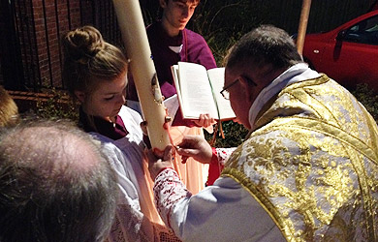

The Second Pillar: The Sacraments — The Faith Celebrated
In the second section of the text it deals with the celebration of the Christian mystery in the liturgy and the Sacraments. Through the Sacraments the Holy Spirit makes available to us the mysteries of God’s revelation in Christ. The saving gifts of Christ’s ministry are encountered in the liturgy and are available to us. This is evident in the Sacraments of Initiation (Baptism, Confirmation, the Eucharist), the Sacraments of Healing (Penance and the Anointing of the Sick), and the Sacraments at the Service of Communion (Marriage and Holy Orders). Through the Sacraments, God shares his holiness with us so that we, in turn, can make the world holier.
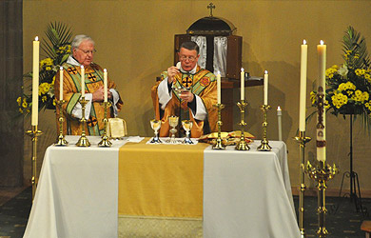

The Third Pillar: The Christian Morality — The Faith Lived
The third section in the books offers an extensive exposition of the foundations of the Christian moral life. Themes of covenant, grace, happiness, sin, forgiveness, virtues, the action of the Holy Spirit, the call to love God and neighbour, the dignity of the person, and the Church’s social teachings are part of the foundational elements for morality. Subsequently, when the Ten Commandments are presented, it us easier to see how the Covenant with God comes first and how the Commandments are ways in which we live out this Covenant. In the Sermon on the Mount, Jesus presents to us a summary of the New Covenant in the Beatitudes. Hence, the Commandments are more than moral laws; our commitment to living them flows from our response to the Covenant we have with God, as members of the Church strengthened by the Holy Spirit.
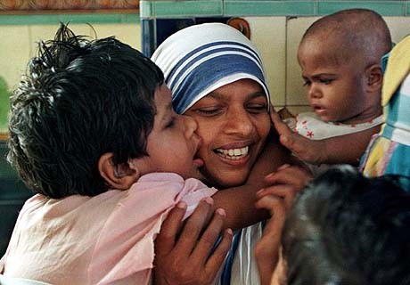

The Fourth Pillar: Prayer: The Faith Prayed
The last section in both books bears an essential relationship to the second section on the liturgy, which is the prayer life of the Church herself. This section deals with vocal prayer, meditation and contemplation, and the types of prayer – adoration, petition, intercession, thanksgiving, and praise. A special chapter is devoted to a commentary on the Our Father, which is the Lord’s Prayer. It seemed suitable here to acknowledge the special link between doctrine and prayer so that a Church teaching is not seen as an abstract idea, and so that prayer not be without a solid doctrinal foundation.
