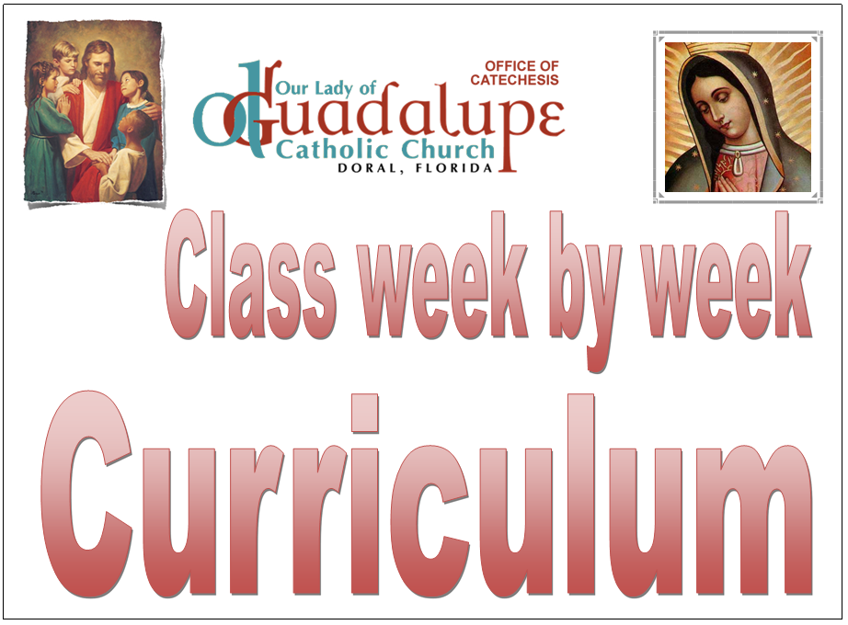

- Here you have the Lesson Plan by dates
- Please if you notice a mistake, let me know
- Remember this is the first year we use this Master Plan, which I believe is great but we will make it better by the end of this year.
- Remember this is a Master Plan… you will need to adjust it to the need of your class
- For tools, ideas and suggested class dynamics, please refer to the
- Confirmation Class Planner
- Material de ayuda para preparar la clase
We will update the material and planner after Christmas.

The First day listed belong to DAHS on Sundays
The Second Day listed belongs to SHELTON on Wednesdays
OCT 1st  OCT 4th | Lesson 1 |  | Why Did my parents make me come?  Introduction to what the Sacrament of Confirmation will do in their life. How God has a plan for us that will make us happy and holy.
OCT 8th  OCT 11th | Lesson 2 |  | Creation of the Universe- A whole new Perspective.  God created out of love. Not because He needed us but because He loves us.  Change the perspective of God the Father as a Punisher, Energy, Indifferent, wizard etc.
 | Lesson 3 |  | Creation – Big Bang, Chaos to Cosmos, Was my great grand father a Chimpanzee?  Understanding the creation not only as a literal sense of the scripture but as a gift from God to humanity.
OCT 15th  OCT 18th | Lesson 4 |  | God’s masterpiece creatures: Man and Woman.  The true mission/call for God’s first children Adam and Eve.  The tree of Good and Evil and the temptation to become like God and decide on our own what is Good and what is Evil.
OCT 22ND  OCT 24th | Lesson 5 |  | Spiritual Realm. Angels what they are and what they are not .  Angels are God’s creatures
OCT 29th no CCD classes at DAHS
NOV 1st no CCD classes at Shelton
INSTEAD Holy Mass at 530 PM in the Parish
NOVEMBER 5th no CCD classes at DAHS
NOV 12th  NOV 8th | Lesson 6 |  | Evil…Oh yes, it’s real!  Spiritual Death. Where does Evil come from and why is so stubborn in destroying souls.  Why God has allow the weed to grow among wheat. Assure the students that the Devil has been defeated  and will never rule the World.
NOV 19th  NOV 15th | Lesson 7 |  | Apple, a bad fruit or a bad decision? (From Adam to Snowhite.)  The gift of free will. It’s obligations and consequences. Consequences of Sin and how  sin does not have to be part of our life. Sin is optional.
WED 22nd & SUND 26th NO ccd classes at DAHS- Thanksgiving
DEC 3rd  NOV 29TH | Lesson 9 |  | White, red, green even Pink!!! What’s up with the colors in the Church?  The Catholic Church is a place of celebrations. The Liturgical Year  The end of it, Feast of Christ The King, Advent, Colors related to every  Liturgical Seasons.
DEC 10th  DEC 13th | Lesson 10 |  | If The Land that Jesus walked is Holy, IMAGINE the womb that bore Him!  The Immaculate Conception of Mary, Mary’s role on the plan of salvation, The  Marian Advocations and Our Lady of Guadalupe Story.
DEC 17th  DEC 20th | Lesson 11 |  | What do you know about Jewish Passover? Does it matter to me?  Why the last plague that kill every first born son in Egypt is so important to understand  Christ as the Lamb of God. How the feast of Passover after that help us understand the  Liturgy of the Eucharist.
From Sunday DEC 24th to JAN 7th CHRISTMAS BREAK
No covered at DAHS  In Shelton JAN 10th | Lesson 12 |  | The Third Person of the Holy Trinity.  The importance of the Holy Spirit in our lives. The renewal of our Baptismal Promises and  How through the Sacraments of Iniatiation we experience the love of God and the  Presence of the Holy Spirit
JAN 21ST  JAN 17th | Lesson 13 |  | The Holy Spirit and His Gifts  Who is the Holy Spirit? His Unopened Gifts. (Wisdom, Understanding, Counsel, Fortitude  Knowledge, piety, fear of the Lord)
JAN 28TH  JAN 24th | Lesson 14 |  | Sanctifying Grace and becoming a Soldier for the Church.  What is Sanctifying grace and how God’s strength can make us become white martyrs  Of our times. Video on the Martyrdom of St. Jose Sanchez del Rio, St Maria Goretti,  St Tarcisious, Difference between Adoration of God and veneration of the Saints.
No CCD at Shelton on JAN 31st
1st Parish Catechist Day – St. John Bosco. Holy Mass for Catechists and Children at
5:30 PM Everyone is INVITED
FEB 4TH  FEB 7TH | Lesson 15 |  | What’s up with the Fruits of the Holy Spirit? Should we eat them?  Love, joy, peace, patience, kindness, goodness, generosity, gentleness, faithfulness,  modesty, self-control and Chastity.
No CCD at Shelton on FEB 14th
ASH Wednesday - Holy Mass for Catechists and Children at 5:30 PM
Everyone is INVITED
No CCD at DAHS on FEB 18TH
President’s Day-Long weekend
FEB 11TH  FEB 21ST | FINAL EXAM AT DAHS  FINAL EXAM AT SHELTON |  | Each catechist will select 5 questions, and submit them to me.  Beside those question each student will need to recite the CREED, 10 Commandments,  The Gifts of the Holy and the Fruits of the Holy Spirit
FEB 25TH  FEB 28TH | Lesson 16 |  | Rite of Confirmation  Opening Prayer, renewal of Baptismal Promises, receiving the Candle, meaning of oils  Used in sacramental celebration.
MARCH 4TH  MARCH 7TH | Lesson 17 |  | The Second Person of the Holy Spirit. Jesus  The Story of a Man and God. His Childhood, His relatives, the beginning of His Public  Life,
MARCH 11TH  MARCH 14TH | Lesson 18 |  | The greatest love on earth, The EUCHARIST.  Facts about the real presence of Jesus in the Eucharist, Eucharistic Miracles, what other  Christian denominations believe. All you need to know about Jesus in the Eucharist.
No CCD from SUNDAY MARCH 25th to SUNDAY APRIL 1st EASTER BREAK

- Retreat and Confessions at our Parish Hall APRIL 7th from 900 am to 200 pm
- REVIEW THE FINAL EXAM
At DAHS on APRIL 8TH
At Shelton on APRIL 11TH

APRIL 15TH  APRIL 18TH | Lesson 19 |  | First the Man, then the Saint.  How God calls us to be the best version of ourselves, not only spiritually but also  Physically. Lesson on etiquette at home and at the Church.
APRIL 22ND  APRIL 25TH | Lesson 20 |  | Renewing our Consecration to Mary  The importance of having Mary as our blessed Mother, Her role as the Spouse  Of the Holy Spirit and Mediatrix of graces.
APRIL 29TH  MAY 2ND | Lesson 24 | We are ready to give our life for God, Now what?  Importance of Apostolate in our lives, Building Community of love and service  for others
MAY 6TH  MAY 9TH | Lesson 25 | Extra Lesson on Chastity and how is calling us to live it in our own vocation.

