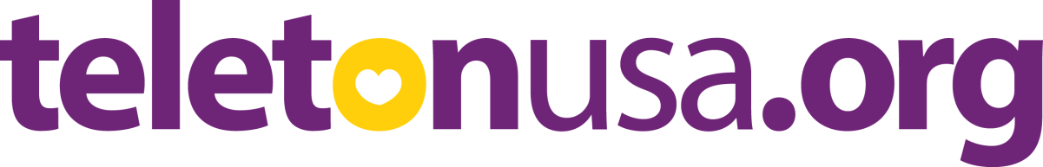
During these days, your children have been receiving piggy banks from Teleton USA Foundation, because our CCD program and our parish will be collaborating to fund raise and help pay for the rehabilitation therapies of children with disabilities.
1. WHAT IS TELETON USA:
What St. Jude Hospital is for kids with cancer, Teleton USA is for kids with disabilities.
2. WHAT IS THE GOAL OF THE FUNDRAISER?
The purpose of this fundraiser is so that our children will put into practice what they learn in CCD. We teach them that we 'must love our neighbor'.
What better way to put into practice the commandment of the Lord through this campaign to help our brothers with disabilities.
3. WHEN SHOULD I DELIVER THE PIGGYBANK WITH MY COLLECTION?
- If your child is in the group on Tuesdays, please deliver the piggy bank no later than November 15
- If your child is in the group on Wednesdays, please deliver the piggy bank no later than November 16
- If your child is in the group on Sundays, please deliver the piggy bank no later than November 20
4. WHO SHOULD I DELIVER THE PIGGY BANK TO?

The piggy banks with the donations should be returned to the CCD teacher.

5. WHERE CAN I SEE THE RESULTS OF MY CONTRIBUTION?

We can see it through Univision on December 2 and 3 during the Great event which airs live from Miami and Los Angeles.

6. WHO CAN I CONTACT IF I WANT MY COMPANY OR FAMILY TO COLLABORATE

You can contact Ms. Lita Lohmann, catechist of our parish and coordinator of the Teleton fundraiser in Florida. e-mail: Lohmann@teletonusa.org phone: 305-968-6452

Our parish deeply appreciates your valuable collaboration, commitment, love and prayers.

God bless you...

